All About Procedures
This document covers the benefits and usage of procedures. It also discusses the difference between procedures and sub routines.

Procedure Benefit Overview
Procedure work similar to subroutines with the following three benefits:
- A procedure can accept parameters
- A procedure can return a value
- A procedure can have its own local variables.
Each of these benefits are discussed in the following sections.

Accepting Parameters
To pass a parameter to s subroutine you have to define global variables, move values in to them and then call the subroutine. This can work well if the variables are already defined and the subroutine just uses them, but if the subroutine gets executed from multiple places and needs different values each time it can get tedious. The following is an example of a subroutine call accepting 3 values in a fixed format program.
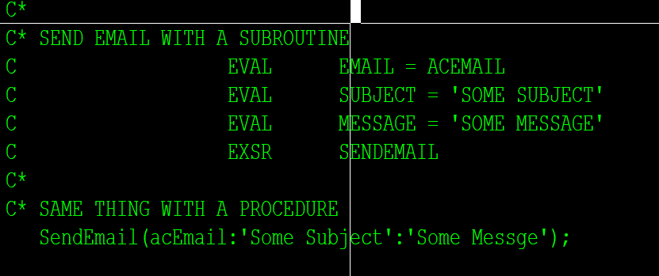
The procedure line removes the need for work variables and removes 3 lines of code to perform the same function. Using long names, the procedure can also be named something that makes them more programmer friendly.

Returning a Value
Procedures can return a value, making them functions. These work just like IBM functions like %Char for example. This allows programs to create UDF’s (User Defined Functions). The #$ functions are examples of user defined functions, but thy can also be created in any program for one time use.

Local Variable
Subroutines only use global variables. This means you have to be careful that any variable you use is not already used somewhere else. Procedures can use their own local variables. So if you define variable X in the procedure and change the value it will not affect the variable X in the mainline procedure.

Procedure Definitions
This document only discusses free format procedure definitions. The fixed format is harder to understand and code. The free format can be used in any fixed format program, so there is not much reason to learn the fixed format version.
Procedures start with Dcl-Proc and end with End-Proc. The following shows the basic syntax.
Dlc-Proc MyProcedure;

// add whatever code you need here

End-Proc;
For coding standards, procedure names should start with an uppercase letter and each new word in the name should also start with an uppercase letter. The rest should be lowercase.
The example above does not return a value or accept any parameters. This makes it work very similar to a subroutine. Every variable reference in to will be a global variable just like a subroutine. The Variable Scope section of this document discusses the difference between a global and local variable.
In a cycle RPG program, converting a subroutine to a procedure just requires changing the BEGSR and ENDSR liens to Dcl-Proc and End-Proc. Once this is done you can add parameters, local variable and a return value if needed, but none of them are required. Since the change is this easy it is suggested that we only use procedures in new code.
Subroutines always exist in a procedure. If you are working one of our regular programs, the main line section of the code is compiled as the main procedure. The compiler will add all required cycle code by default. This why you have to set on *INLR when closing a program. The cycle code opens all your files for you, unless they have the keyword USROPN. When the program ends with *INLR on the program preforms cleanup which includes closing the files and releasing the memory reserved for variables and removing the program itself from memory. Any subroutines added to a cycle program are automatically included in the main procedure unless they are in another defined procedure.
Since subroutines are local to procedures you can technically use the same subroutine name in two different procedures. However since we no longer want to use subroutines this should never happen. Even if you are working on an old program with subroutines and adding a procedure, please do not duplicate the subroutine names, it just makes it confusing for people later.
Adding parameters, return values and local variables are described in the sections below.

Adding Local Variables to a Procedure
Since a procedure is similar to the main line of a program, it has its own declaration section. In a main program the declaration section is at the top of the program, before any calculation specifications. In a procedure it is the same. After the Dcl-Proc statement you can declare anything else you need. These have to come before any calculation specifications in the procedure, just like they do in a program.
The following example continues the MyProcedure example above but declares its own variable and uses it for the iteration counter on a for loop.
Dlc-Proc MyProcedure;
Dcl-S I packed(5);

For I = 1 to 10;
End-For;

End-Proc;
In this example “I” is defined as a local variable to the MyProcedure function. “I” can be defined in the main procedure or any other procedure in the program, but in the MyProcedure procedure it is its own variable and therefore will not change the value of any other variables named “I” in any other procedures.
A procedure can have as many variables as it needs, it can also had its own data structures and about anything else defined on D specs or Dcl-XX specification.
The main benefit is that you no longer have to ensure that a variable name is not used anywhere else.

Adding Parameters to a Procedure
Parameters are added to a procedure using a procedural interface declaration. This is also how you define parameters for the main procedure in a free format program. A procedure interface starts with a Dcl-Pi and ends with an End-Pi. Parameter fields are listed between the declaration and ending statements. Each parameter becomes a local variable that is populated with the data passed to the procedure.
The following example shows MyProcedure setup to accept a numeric variable for times to loop.
Dlc-Proc MyProcedure;
Dcl-Pi *n;
timesToLoop packed(5);
End-Pi;
Dcl-S I packed(5);

For I = 1 to timesToLoop;
End-For;

End-Proc;
Notice on the Dcl-Pi line there is a *n, normally Dcl-Pi would have the procedure name the procedural interface is being defined for. However *n just says that this is the procedural interface for the procedure it is in. This should be used instead of hardcoding the name so the code can be copied without having to change it as much in the future.
After the Dcl-Pi line there is variable called timesToLoop. This is defined as packed with a length of 5. Since no decimal positions where specified 0 decimal positions are assumed. The syntax for this line is the same as a Dcl-S without the Dcl-S. Since it is in a procedural interface definition, the compiler knows that each line will define a parameter. This is also the same format for fields in a data structure. Then the End-Pi line just tells the compiler that you are done defining the procedural interface.
The for loop has also been modified to loop the passed number of times.
To call this procedure from anywhere within the program you would use this syntax:
Dcl-S timesToLoopPassed packed(5);
timesToLoopPassed = 5;
MyProcedure(timesToLoopPassed);
In this example the data passed to the procedure must be packed with a length of 5 or the variable timesToLoop will have an invalid value. This is because parameters are passed as pointers to a location in memory. The procedure only gets the memory pointer and it knows that it is a packed field so it knows to look at the next 3 bytes to get the packed data, if that pointer is not to a packed variable then it get funny results.
Using procedural interfaces the compiler will ensure that the values passed to a procedure match the types and lengths defined on the procedural interfaces. In the example above, if timesToLoopPassed was defined as packed(7) the program would not compile.

The Value Keyword
The solution to miss matched numeric parameters this is the value parameter. Adding the value keyword to the field definition tells to program to map the value into the receiving field. This means you can pass any variable that can be converted to packed(5) as a parameter. It also allows you to pass a constant as the value.
The procedural interface now looks like this:
Dlc-Proc MyProcedure;
Dcl-Pi *n;
timesToLoop packed(5) Value;
End-Pi;
Dcl-S I packed(5);

For I = 1 to timesToLoop;
End-For;

End-Proc;
The procedure can now be called like any of these examples:
Dcl-S timesToLoopPassed packed(7);
Dcl-S timesToLoopPassedInt int(5);
timesToLoopPassed = 5;
timesToLoopPassedInt = 5;
MyProcedure(timesToLoopPassed);
MyProcedure(timesToLoopPassedInt);
MyProcedure(5);
In all these examples the timesToLoop parameter in the procedure will receive the value 5. It can be passed as packed(7), an integer or a constant value. It is good practice to always use the value keyword on numeric variables. It makes the code more reusable. There is a little processing overhead, but it should be unnoticeable.

The Constant Keyword
Another useful keyword on fields in a procedural interface is Const. It stand for constant. It allows character data to be passed as a constant or a variable. When used in conjunction with the parameter type Varchar, any constant, Char or Varchar field will be mapped correctly to the input variable.
The following program uses a procedure to send an email with a passed subject. 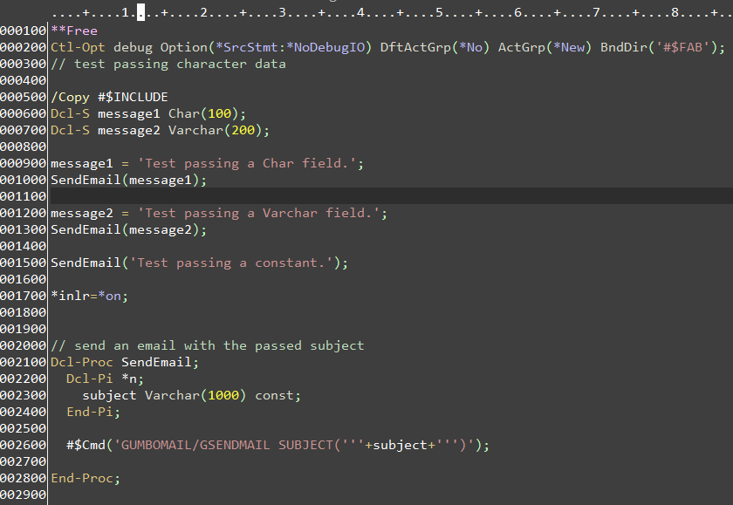
Notice line 2300 has the constant keyword. That means that the subject can be passed as a constant or anything that can be mapped to a Varchar(1000) field. The main procedure of the program calls this procedure with a Char(100) a Varchar(200) and a constant field. Each email was sent with the proper subject.
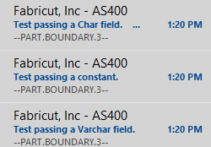
If the Subject parameter was defined as a Char(100) without the Const keyword, exactly 100 characters of data would have to be passed to the procedure as a variable. If only 50 were passed the remaining fifty characters would be what ever happened to be in the next 50 locations in memory. This could produce undesired results.
The only downside to the Const keyword is that no changes can be made to the subject keyword within the procedure. This is because if the value is passed as a constant, there would be no place to return the changed value to.
As a general rule it is good practice to pass all character data as a Varchar with the constant keyword, unless you are wanting to use a variable to return a changed value in.

Optional Parameters
Procedures can have optional parameters just like programs. In fact the same method is used in the procedure as is used in a program. The procedure must test for the number of variables passed before it tries to use a parameter. If the parameter was not passed it cannot be used or a null pointer error will be raised.
The RPG compiler however does verify that a procedure is being passed the correct number and types of values, so it has to be told to make a parameter optional. This is done using the options keyword with a value of *NOPASS. The example below continues the send email example, but adds an additional optional parameter of the email address. If an email address is not passed it used the default for the current user, if one is passed it sends it to that address. The procedure is then called with and without the email address so it can be tested.
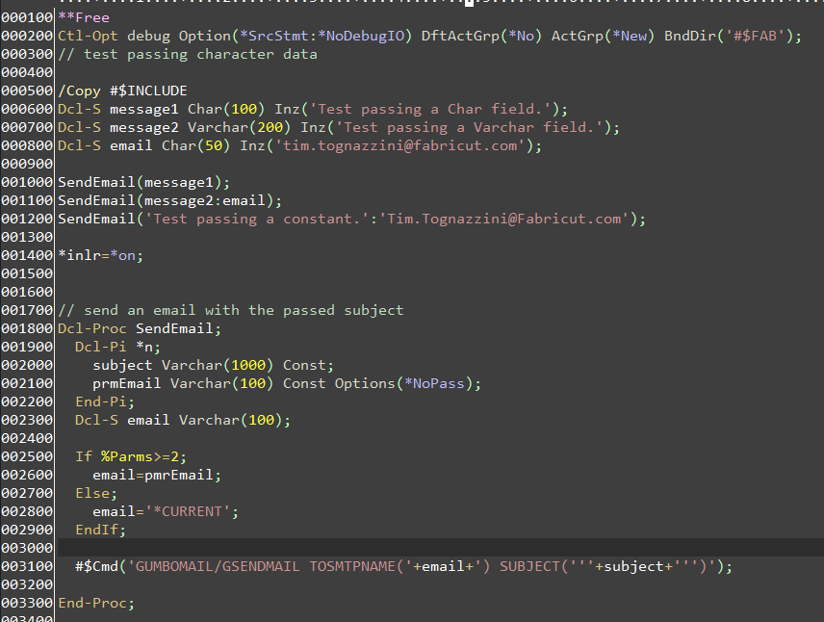
Notice in the procedure there is a local variable named email. If the second parameter is passed the email variable is set to it. However if the second variable is not passed it is set to *CURRENT. With the Options(*NoPass) defined the compiler will allow the procedure to be called with 1 or 2 parameters. Also since pmrEmail has the constant keyword it can be passed as in variable or a constant. Lines 1000 to 1200 call the procedure with different parameter combinations.

Omitable Parameters
In some cases you need to have optional parameters after other optional parameters. This can create an issue where the first and third parameter is needed but the second is not.
Continuing the email example above, we are going to add a third parameter for the email message. If the subject and message are passed but we want to leave the default of the current user for the email address we have to omit the second parameter.
The special value *Omit is passed. The compiler needs to also know that this is allowed so the Options(*omit) value is added to the parameter. Unfortunately we now actually have 3 parameters, so just checking the count will no longer work. We now have to check the count and the address of the parameter to ensure it is not null.
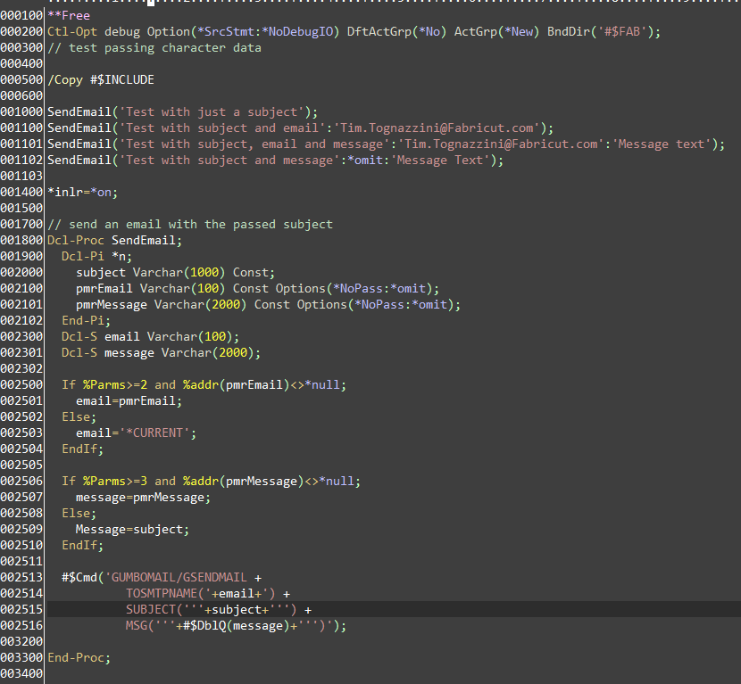
Notice that work variables were defined for both the email and message since they are optional. Lines 2500-2504 handle the optional omitable email address variable. It test for the number of parameters passed and ensures that the parameter was not omitted by making sure the address for the parameter is not null. Lines 2506-2510 do the same thing for the message. The message should just be excluded instead of omitted if it is not needed. But for future proofing the code it is best allow all *nopass variables to also allow *omit. That way if another parameter is added in the future the code would already handle.

Adding a Return Value to a Procedure
Procedures can return values as well. These are normally called functions. Programers should already be used to working with function via the BIFs (Built In Functions) provided by IBM. Some examples are %Char, %Dec, %EditC and so on. A function can accept parameters or not and returns a value. In the last example a UDF (User defined Function) was already included. The #$DblQ function was used on the message to double up any quotation marks in the message so the command did not receive an error.
Return values are specified on the procedural interface on the Dcl-Pi line. The first parameter of Dcl-Pi is the procedure name, normally defaulted to *n. The second optional parameter is the return type. The return types are the same types as variables can be defined as or a data structure. For Example the #$DblQ function accepts a string and returns a varchar. The entire procedure looks like this:
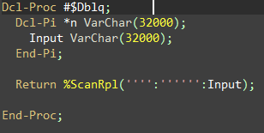
It just accepts a character value and returns the same value with a quotation marks doubled up.
If you add a return type the Return operation must be used and it must return a value of the same type as the procedural interface is defined as.

Variable Scope
Variable scope refers to where a variable exists. In the fixed format cycle program we are used to writing every variable is a global variable. Using procedure we can start to use local variables to prevent reusing existing variables. In RPG a variables scope can only be global or fixed. In object oriented programming there are more levels of scope, but that will not be discussed here since it does not apply to RGP.
A variable declared outside of any procedure is global. It can be used in nay procedure or subroutine in the program.
Variable declared in a procedure is local. It can only be used in the procedure it is defined in.
Variable conflicts are resolved using the lowest level variable. For instance if a variable named X was defined as a global and then again in a sub procedure, in the procedure X refers to the local variable X, anywhere else in the program X refers to the global variable X.
The following example shows variable x being defined both as a global and a local variable. It compares it to variable y which is just defined as a global variable.
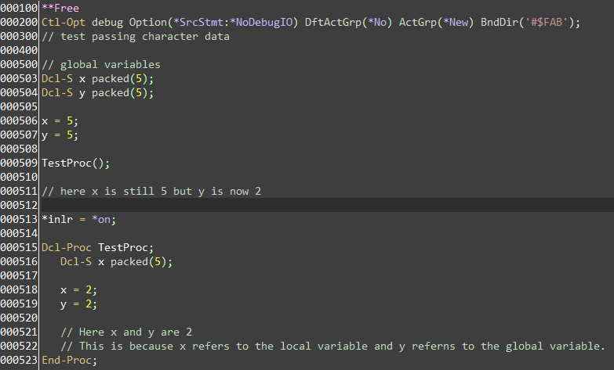

Handling Parameters in Free format Code
In free format code you cannot use the PLIST operation code. It has been replaced with the procedural interface. Just like we defined parameters for the procedures above we can define them for an RPG program. The following example shows a program that accepts a fabric number as a parameter.
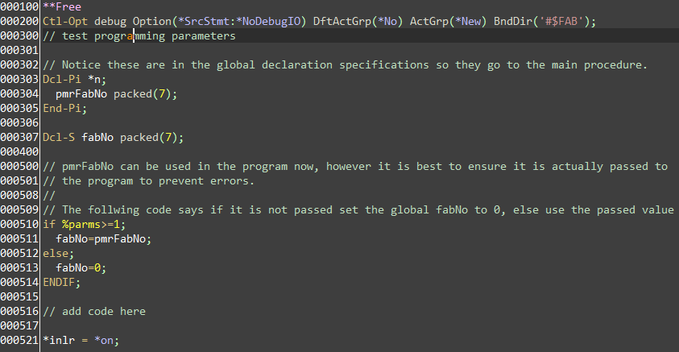
If you want to call this program form another program you have define a prototype in the new program. A prototype tells the compiler what the allowed parameters are for the program. When using a local procedure the compiler can just look at the procedural interface to tell what must be passed and how. But since programs are external resources, the compiler cannot look to see what they need.
The prototype is very similar to the procedural interface, but they do not actually define variables. They are jut the set of instructions required to tell what parameters an extern program or procedure needs. The following example show how a prototype would be defined for the example above.
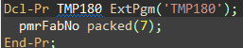
You can see how this looks similar to the Dc-Pi with the Pi changed to PR. The main difference is the stuff after the Dcl-Pr. The first value listed is the name, on the Dcl-Pi we used *n to make it the same as the procedure it was defined in. Here we have to give it a name. After the name we set the external program to call. This tells the compiler to call the program TMP180 when this is used. The name does not have to match the external program, but keeping them the same keeps programmer sane.
The variable name for the parameter is also completely ignored by the compiler. It can be changed to *n to denote nothing. The following example shows the name changed and the parameter name left off.
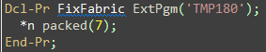
No when Fixe Fabric is called the program will call the external program TMP180. The parameter still has to be packed(7), having the name helps make it easier for programmers to realize what the parameter is for. As a general rule, do not change internal and external names and leave variable names in the prototype. This is actually easier when writing them anyways. Just copy the Dcl-Pi, change the Pi’s to Pr’s add the program name and the external name.
Prototypes should be defined in copy books and copied into programs where they are used. They should also be copied in the program that they called. Copying them into the program that they call ensures that they match the Pi, if they do not the program will not compile. Having everything that calls them use the same copy book ensures that every other program uses parameter options.
Using the new Fabricut naming convention we create a source member with the same name as the program and a PR on the end to hold the prototypes. For example DCTMSTD1 also has a member called DCTMSTD1PR that contains the prototype. DCTMSTD1PR is copied into DCTMSTD1 to ensure the parameters match. Any program that calls DCTMSTD1 also copies in the prototype. This forces any program that calls DCTMSTD1 to use the correct parameters since the calling program will have the prototype the compiler can enforce parameter requirements.
The following code snippet shows the top lines of the code for DCTMSTD1:
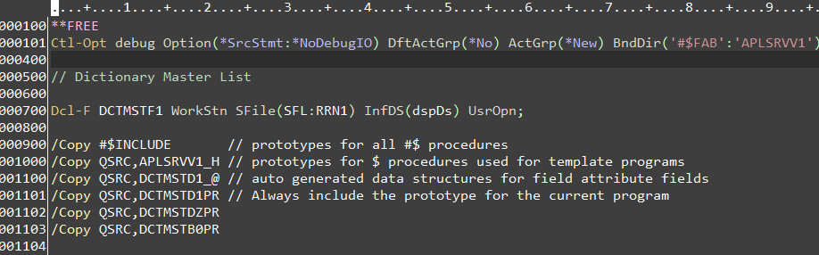
Notice on line 1101 the prototype for this program is included. The next 2 lines copy in prototypes for the programs DCTMSTDZ and DCTMSTB0PR.

The Main() Ctl-Opt (Not Using the Cycle)
This document referenced all programs as having a main procedure that automatically has the cycle code added. This is true by default, but it can be avoided. By not including cycle code a program can be smaller and ever so slightly more efficient. The small overhead created for cycle code is irrelevant if any of the cycle code is actually used. It is better to leave it then avoid it. However since newer programs do not open any files and free format code does not handle input primary files, there is essentially no reason to keep the cycle code.
To make a program exclude all cycle code, you use the Main option in the control options. The main option accepts a parameter for the initial procedure. The following example shows a program that excludes all cycle logic.
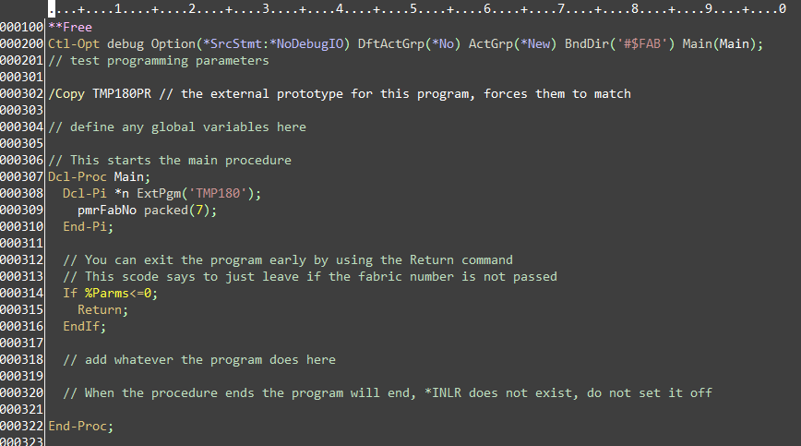
Notice on line 200 there is an option Main(Main) this tells the compiler that the procedure Main is the main entry procedure. The Dcl-Pi in the main procedure becomes the program parameters. The copy book for the prototype ensures that the prototype matches the procedural interface.

